Online DPC Module

1. User Authentication (Screen 1)

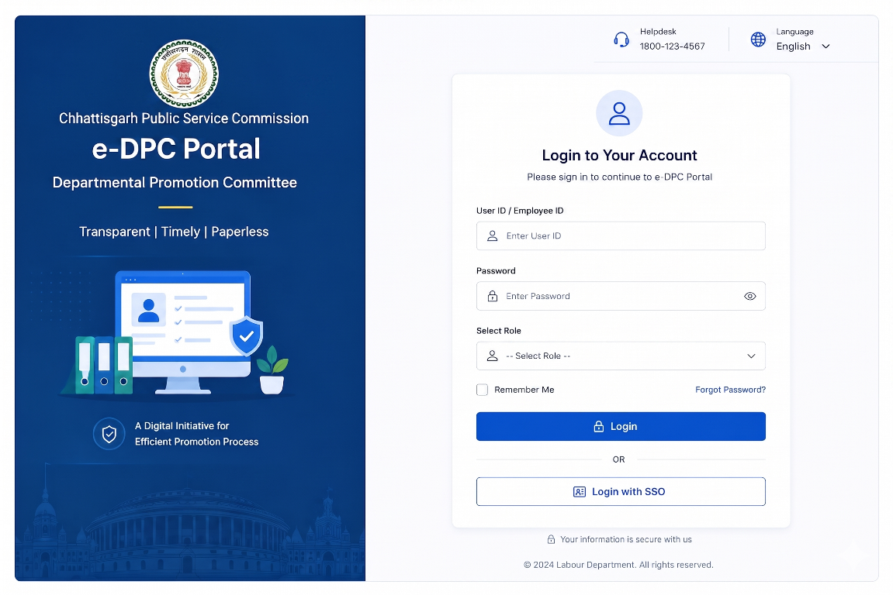
2. Dashboard Analytics (Screen 2)

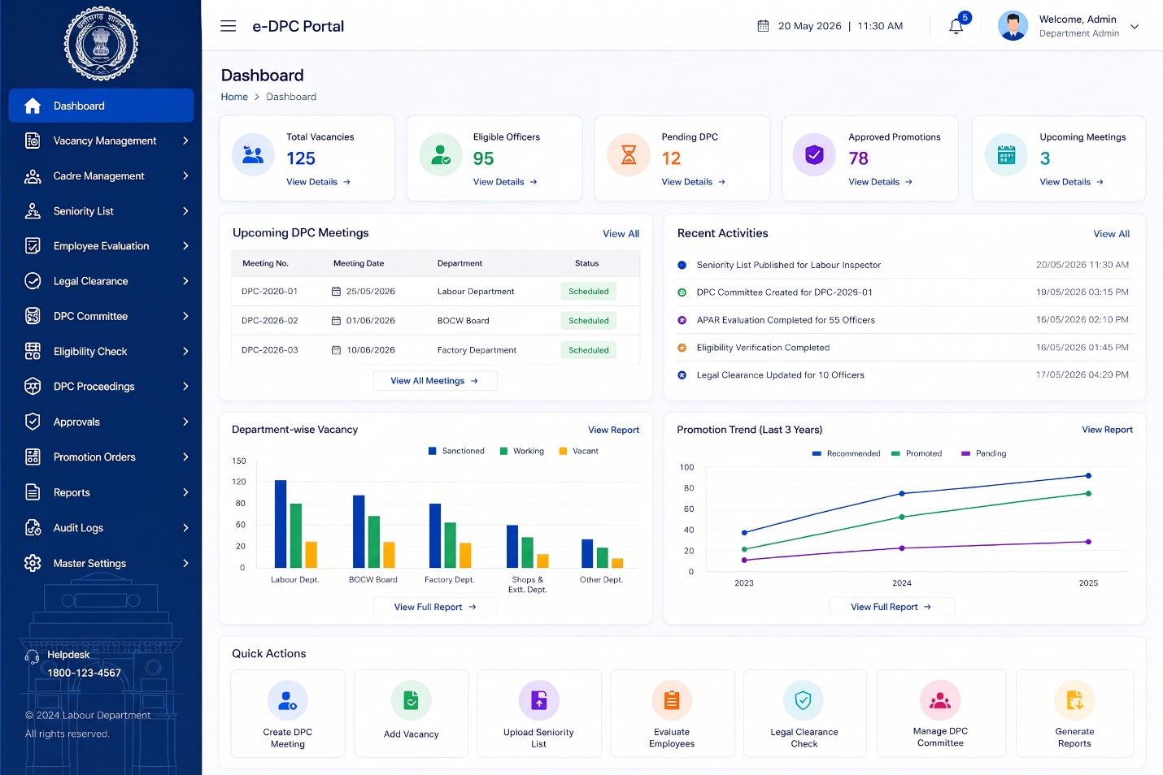
3. Vacancy Management (Screen 3)

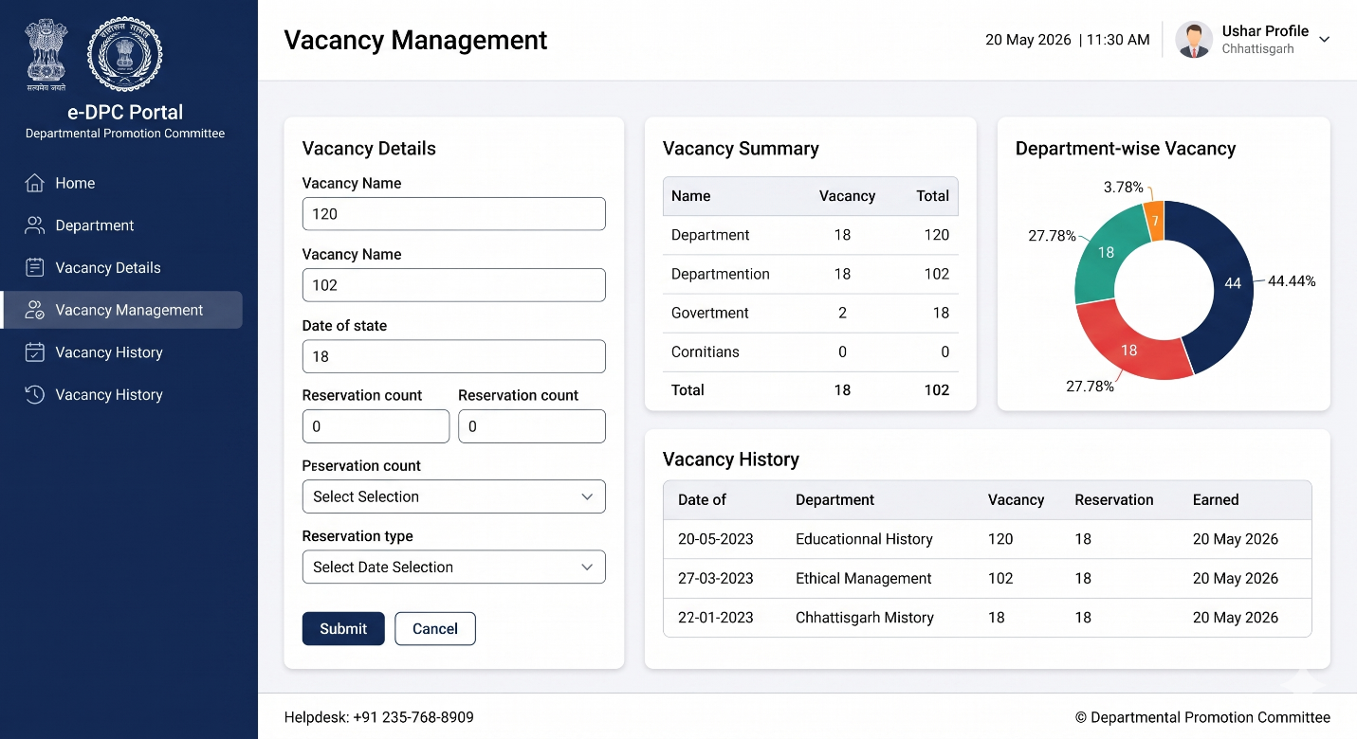
4. Feeder Cadre Management (Screen 4)

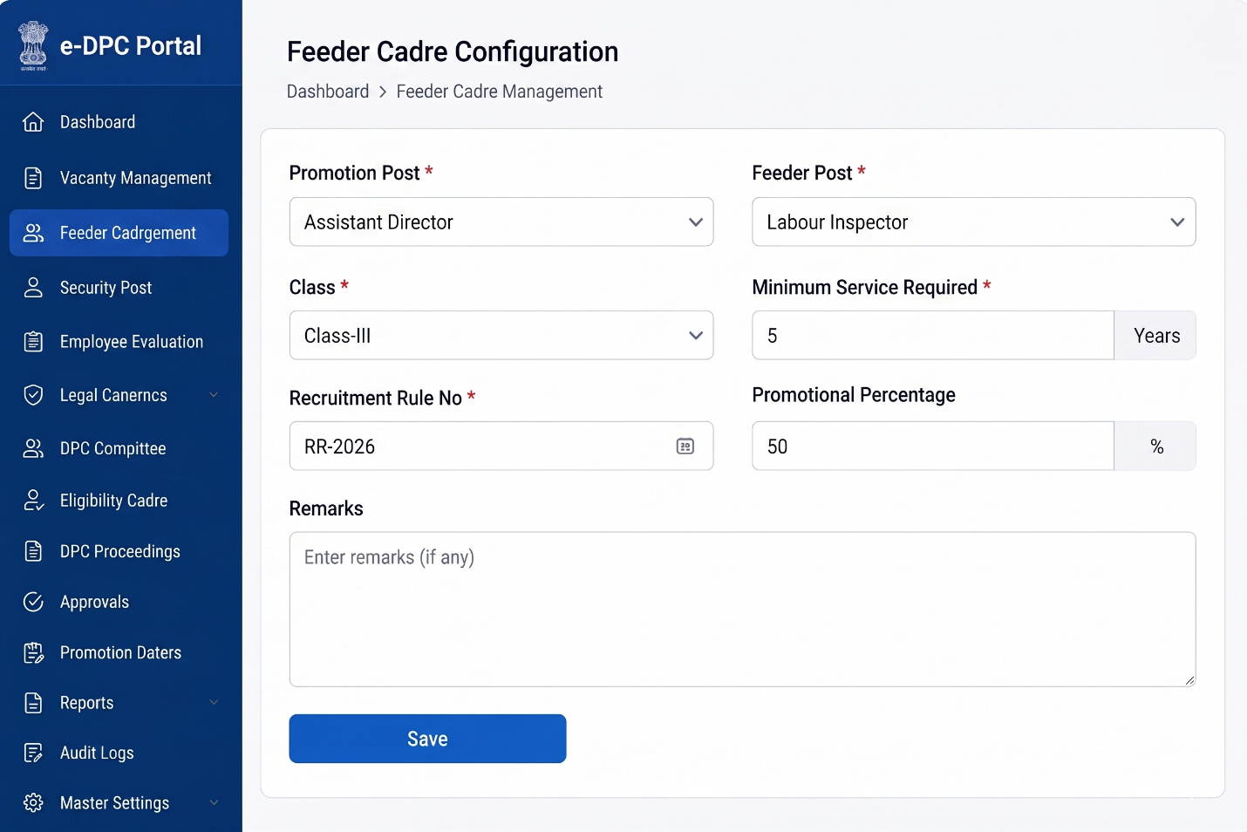

5. Seniority List Management (Screen 5)

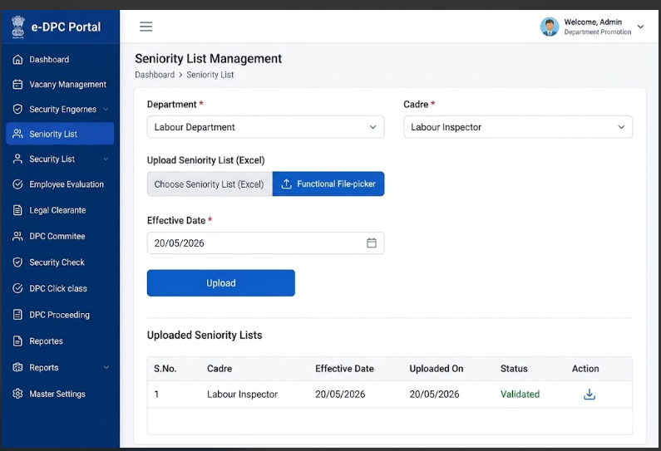

6. Employee Evaluation (Screen 6)

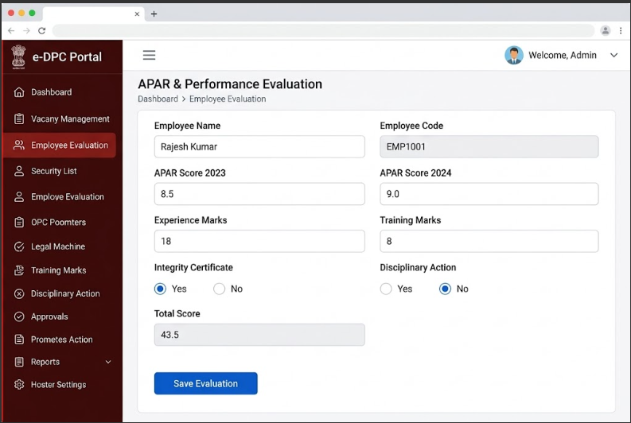

7. Legal & Vigilance Clearance (Screen 7)

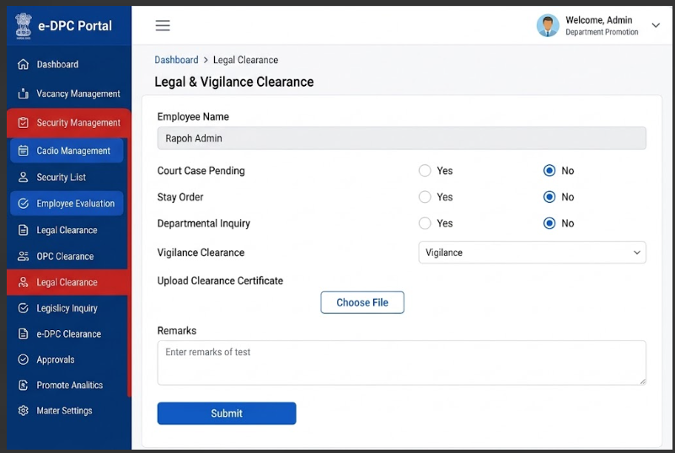
8. DPC Committee Formation (Screen 8)

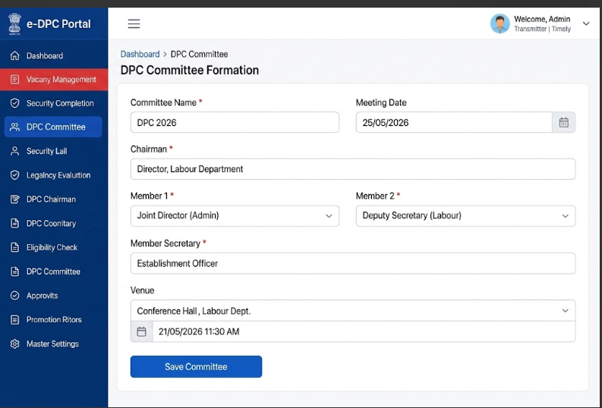

9. Eligibility Verification (Screen 9)

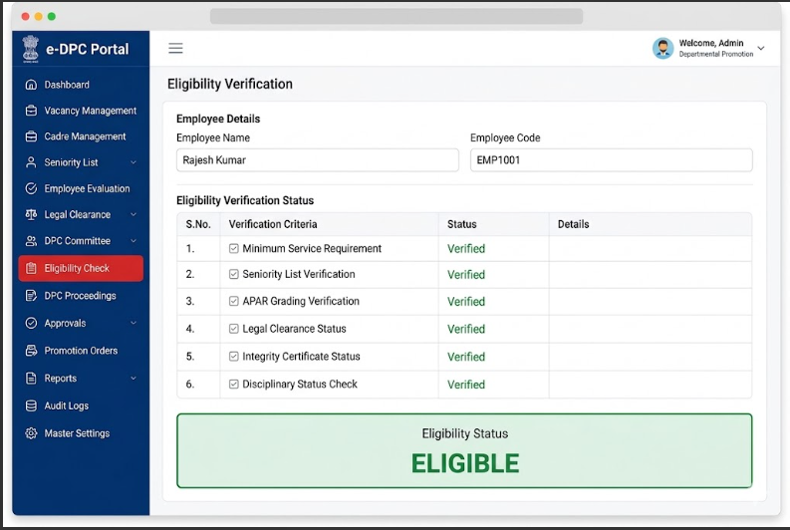

10. DPC Proceedings (Screen 10)

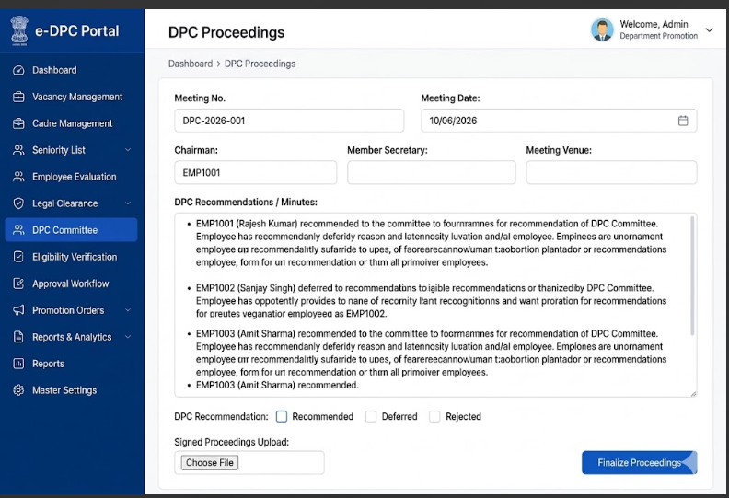

11. Approval Workflow (Screen 11)

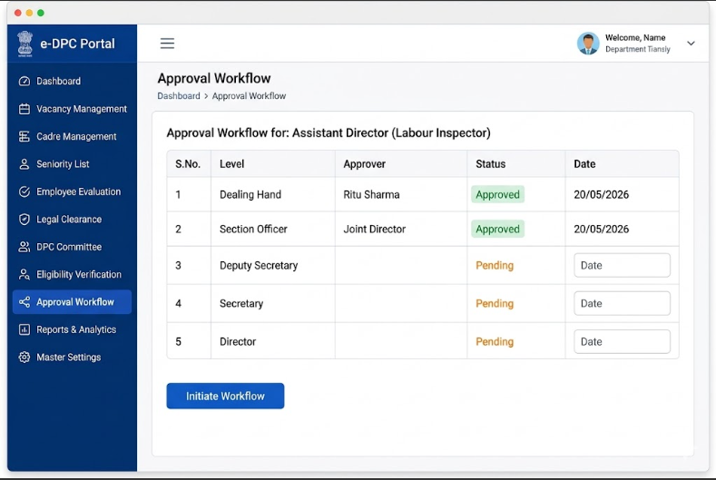

12. Promotion Order Generation (Screen 12)

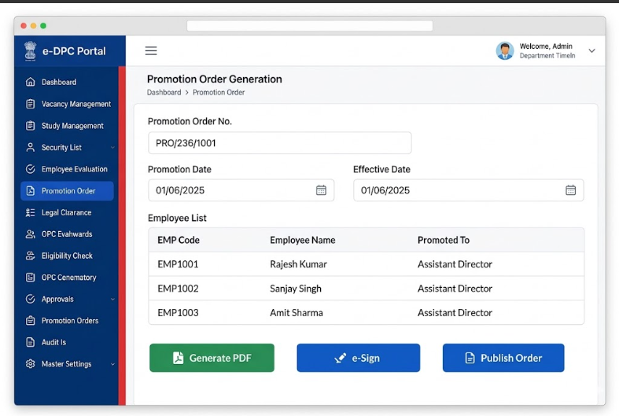

13. Reports & Analytics (Screen 13)
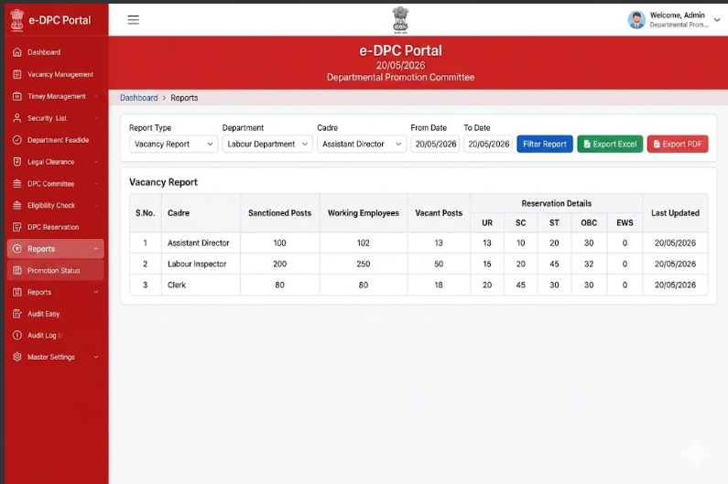

14. Final Promotion Order – Publication & Distribution

